[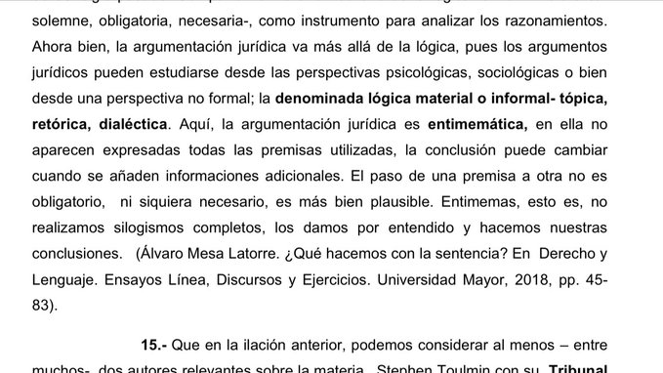](https://twitter.com/maxmurath/status/1359952188936699906/photo/1)